**Project 1**

**Problem Statement: A bank has given data of user, bank wants you to make a model that can be used to predict customer defaulter on his EMI payment.**

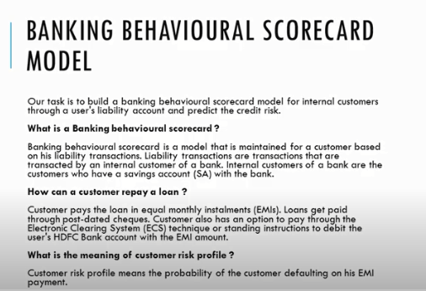

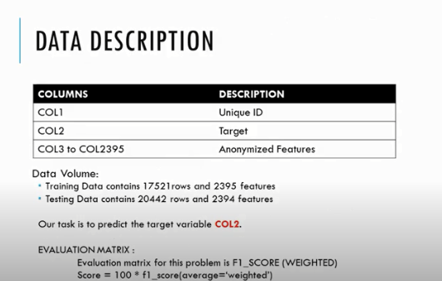

**Data Set**